**Obstacle Avoidance Robot**

**1.Introduction**

The ability to detect and avoid obstacles in real time is an important design requirement for any practical application of autonomous vehicles.

This lesson presents the algorithm for obstacle avoidance relying on ultrasonic or infrared sensors, and involving a reasonable level of calculations, so that it can be easily used in real time control applications with microcontrollers.

The algorithm that is presented in this lesson is called “The bubble algorithm”. Initially, the robot moves straight, if an obstacle is detected within the “sensitivity bubble”, the robot moves in a direction found as having the lowest density of obstacles, and continues its motion in this new direction.

**2.Dependencies**

For this program to run optimally you need the next setup:

* Ubuntu 18.04.5 LTS or a Virtual Machine with Ubuntu 18.04.5 LTS
* Gazebo 11
* ROS Melodic Morenia

All the installation tutorials will be in “Chapter 1”

**3.Installation**

All the commands below must be run in a terminal. To open o new terminal press CTRL+ALT+T or RIGHT CLICK and Open Terminal.

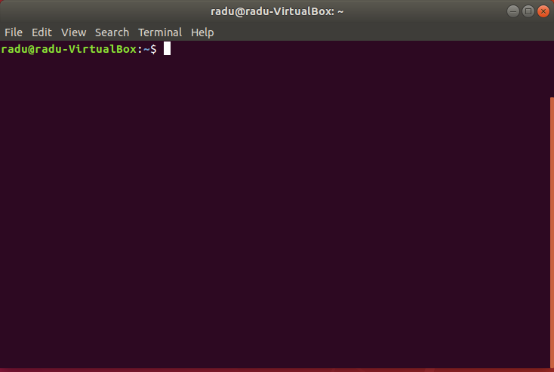

Terminal commands are highlighted in yellow.

Se lanseaza in executie programul(Downloading the program from Github,……)

**ObsAvoid**

**Obs!!**

If the download from GitHub is successful, the next message will appear.



We will change the folder to:

**cd obsavoid**

**catkin_make**

The catkin_make command is a convenience tool for working with catkin workspaces(a catkin workspace is a folder where you modify, build, and install catkin packages).

For every shell that launches programs you need to run this command, to make sure your workspace is properly overlayed by the setup script.

**source devel/setup.bash**

**4.Running the program**

For this program we need to spawn a world first. We have to choose between 2 worlds.

**World1(an empty world)**

**roslaunch my_worlds world1.launch**

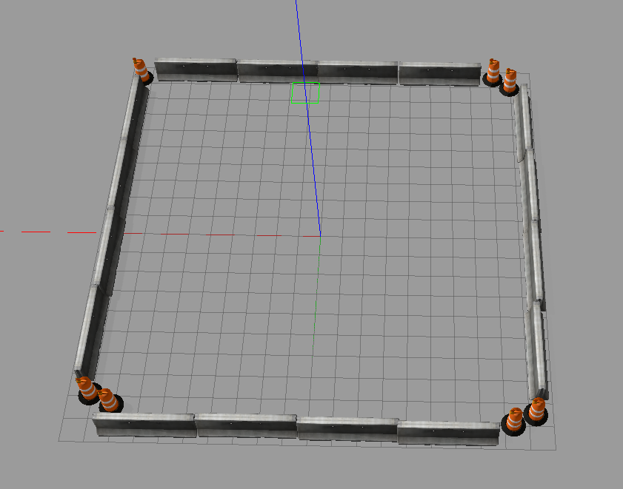

**World2(rectangular form with circular form in the middle)**

**roslaunch my_worlds world2.launch**

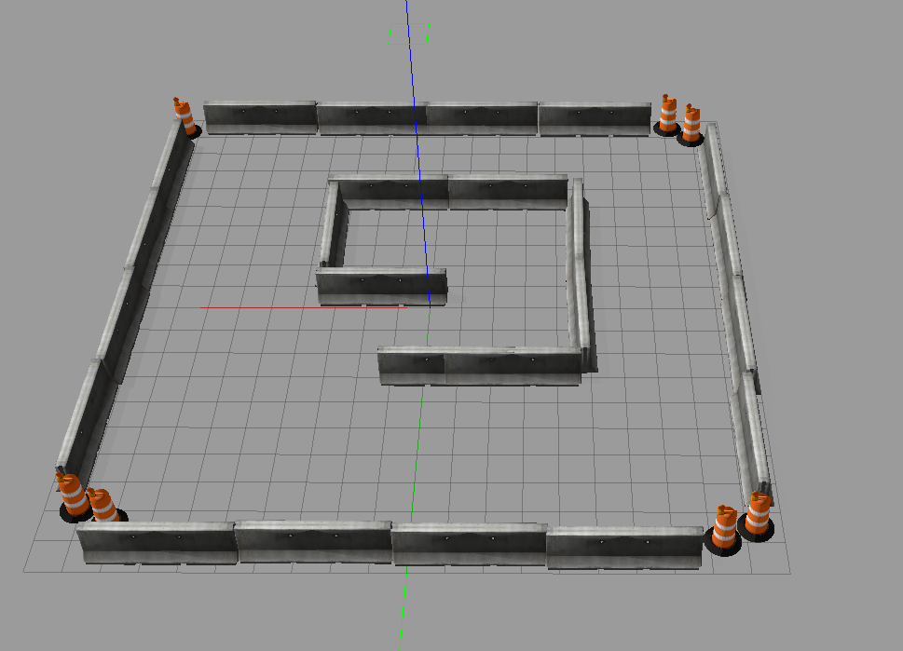

In a new terminal,run the command for spawning the robot.



**roslaunch robot_description spawn.launch**

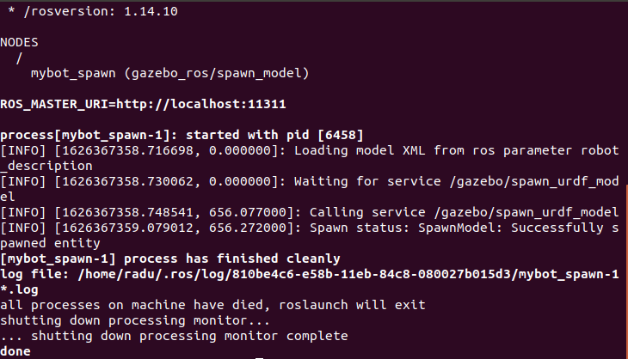

When this message appears the robot was spawn successfully.

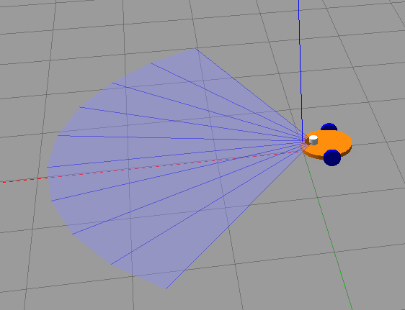

The robot for this program consist of a two wheeled robot combined with a laser scanner on top for detecting the obstacles.

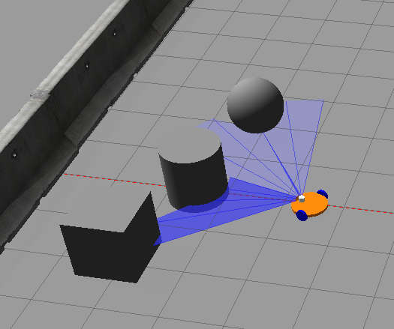

The final step is to run the Obstacle Avoidance program,which will start automatically after running the command.



**rosrun motion_plan obstacle_avoidance.py**

The output for this program is different cases when laser sensor detects obstacles around the robot.



**Spawning obstacles for robot.**

We can spawn simple objects(you can add them by pressing the top buttons with shape figures from gazebo) or you can add your own objects and spawn them in gazebo.

